MY NEW SCHOOL TIMETABLE AT JOHANNES-WIDMANN-SCHOOL
JWS
Bringe deine Schultage in die richtige Reihenfolge:
Tuesday, Friday, Wednesday, Monday, Thursday
8.00-8.45 |  | 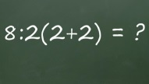
8.45-9.30
Pause

9.50-10.35 |  |  | 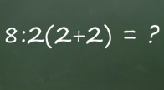
10.35-11.20 | IL |  |  |  | IL
Pause
11.40-12.25 |  | IL
12.25-13.10 |  | IL
Pause

14.30-15.15
15.15-16.00
Was passt?
biology chemistry music English science German
history art maths special instruction geography physical education
religious education physics ethics individual study

